**MOBILE WEB CLIENT APPLICATION**

In this mobile web client application, we have four different modules incorporated.

First,we will have the home page where from where we can transit to other pages.

**HOME PAGE:**

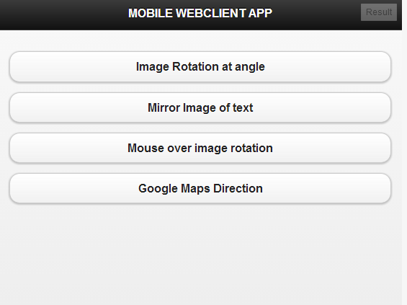

By clicking these buttons we can transist to respective pages.

**Image Rotation At Angle**:

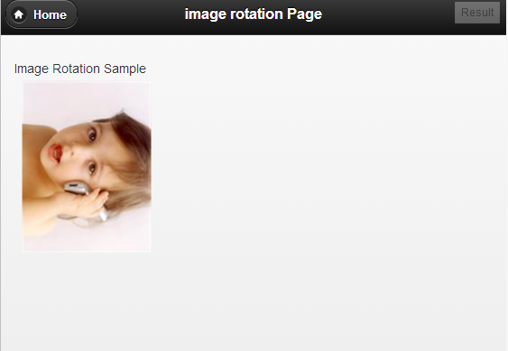

We can insert an image at an angle.

$("#baby").rotate(90); //JQuery statement

In the above line , we can give the angle as we wish. Here 90 is given so the image is rotated 90 degrees.

Here we have home button ,by clicking it we can navigate to home page.

**Mirror Image Of Text:**

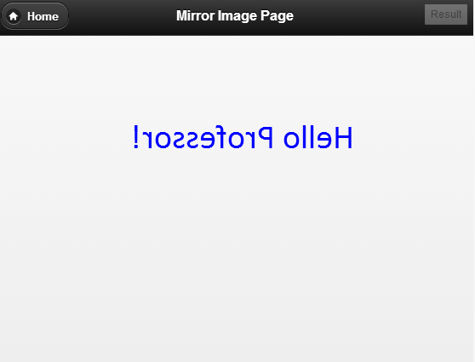

This shows the mirror image of the text entered.

variable.fillText(**'Hello Professor**!', 0, 0); //javascript

Here in the parenthesis if we give other word the mirror image of that gets displayed.

Using home button we can transist to home page.

**Mouse Over Image Rotation:**

In this module the image rotates when the mouse is over it.

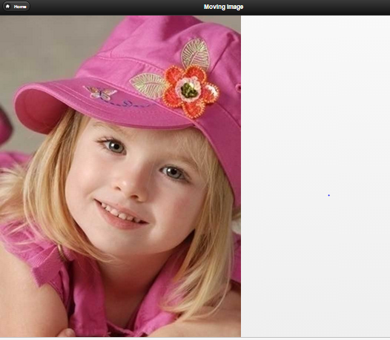

The above image is when the **mouse is not on the image**.

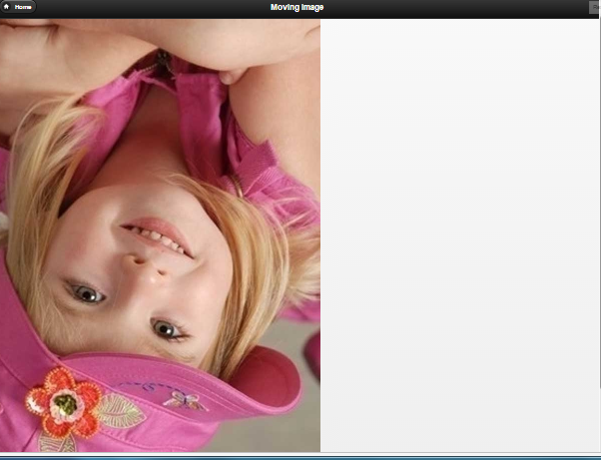

The above image is when the **mouse pointer is over the image**.

$(this).rotate({animateTo:**180**}) //JQuery statement

In the above statement we gave 180 degrees rotation. So, when we place the mouse over the image it rotates 180 degrees. If we palace another value.It rotates to that value.

GoogleMaps Direction:

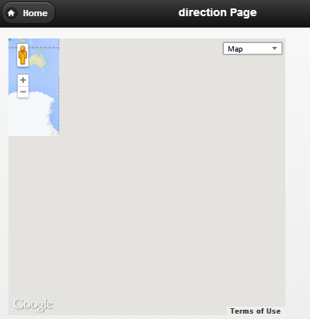

We just need to zoom out the direction.

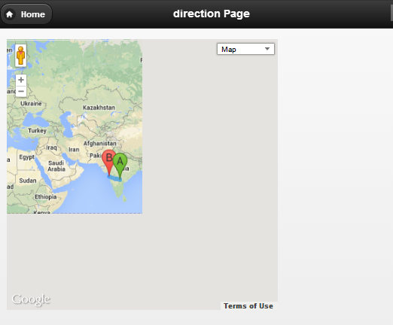

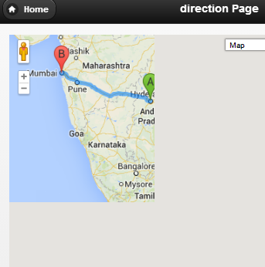

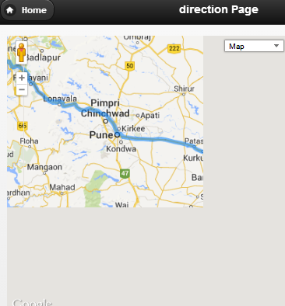

As, we zoom in we get the directions from the source to destination.

var start = "Hyderabad"; //Set the source/ origin

var end = "Mumbai"; //Set the destination

Here the source and destination are given and the roadmap route is shown.

If we give other source and destination we get other routes.

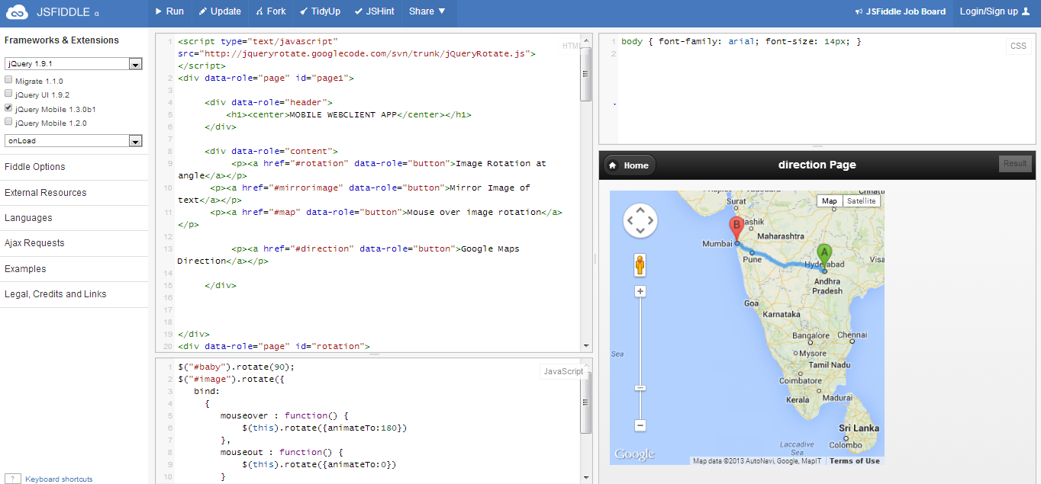

JSFIDDLE LINK :

<http://jsfiddle.net/dSNxG/92/>